Computational Stratification of BRCA1 Missense Variants: Defining Mechanisms of Pathogenicity Precision of Breast-ovarian cancer
Thesis submitted for the partial fulfilment of the Degree of
MASTER OF SCIENCE
In Biotechnology
Submitted by
ANKESH BASHIST
2418947



Chandigarh College of Technology
CHANDIGARH GROUP OF COLLEGES, LANDRAN,
MOHALI, PUNJAB, INDIA
JUNE, 2026

DECLARATION BY THE CANDIDATE

I hereby declare that the thesis entitled, “Computational Stratification of BRCA1 Missense Variants: Defining Mechanisms of Pathogenicity Precision of Breast-ovarian cancer” submitted in partial fulfilment for the award of degree of Master of Science to Chandigarh Group of Colleges Landran, Mohali, Punjab India is original research work carried out by me under the guidance and supervision of Dr. Bhairav Prashad.
No part of this thesis has been submitted for any other degree or diploma to this or any other College and university.

(Signature of student)

Ankesh Bashist

Place:
Date:
CERTIFICATE-I
This is to certify that the thesis entitled, “Computational Stratification of BRCA1 Missense Variants: Defining Mechanisms of Pathogenicity Precision of Breast-ovarian cancer” submitted in partial fulfillment for the award of degree of Master of Science to Chandigarh Group of Colleges Landran, Mohali, Punjab India, is original research work carried out by Ankesh Bashist (2418947) under my guidance and supervision. No part of this thesis has been submitted for any other degree or diploma to this or any other institute and university.
The assistance and help received during the course of investigation has been duly acknowledged.

(Signature of Guide)
Dr. Bhairav Prashad
Assistant Professor
Department of Biotechnology
Chandigarh College of Technology,
Landran (Mohali)

Place:
Date:
CERTIFICATE-II
The thesis entitled, Computational Stratification of BRCA1 Missense Variants: Defining Mechanisms of Pathogenicity Precision of Breast-ovarian cancer submitted by Ankesh Bashist (2418947) Chandigarh Group of Colleges Landran, Mohali, Punjab India, in partial fulfilment for the award of the degree of Master of Science has been approved by the student’s Research guiding committee after an oral examination of the same.

Name & Signature of Guide

Name & Signature of Research Guiding Committee Members

Name and Signature of HOD
CHAPTER | TITLE | PAGE NO.
 | Acknowledgement  List of Tables  List of Figures  Abstract | i  ii  iii  iv
1 | Introduction | 1-3
2 | Review of literature | 4-8
3 | Materials and Methods | 9-14
4 | Results | 15-21
5 | Discussion | 22-24
6 | Conclusion | 25
7 | Future scope | 26-27
 | References | 28-29

ACKNOWLEDGEMENT
I wish to express my profound gratitude and indebtedness to Dr. Bhairav Prashad, Department of Biotechnology, Chandigarh College of Technology, Landran (Mohali), for introducing the present topic and for his inspiring guidance, constructive criticism, and valuable suggestions throughout this project.
My sincere thanks and appreciation also go to my lab colleagues, who willingly offered their support and assistance during the completion of this work.

Ankesh Bashist (2418947)

LIST OF TABLES
Table No. | Title | Page No.
2.1 | Comparative Features of Homologous Recombination (HRR) And Non-Homologous End Joining (NHEJ) | 4-5
3.1 | Selection of Candidate Variants From Cohort | 10
3.2 | Structural Template Selection For Computational Modeling | 10
3.3 | PyMOL Visualization And Rendering Protocol | 14
4.1 | Multi-Platform Bioinformatics And Machine Learning Pathogenicity Matrix For Selected Brca1 Variants | 15-16
4.2 | Mechanistic Stratification of Brca1 Pathogenic Variants | 17
4.3 | Biophysical Mechanisms of Interfacial Binding Disruption | 21

LIST OF FIGURES
Figure No. | Title | Page No.
Figure 2.1 | 1JM7 (N-Terminal RING Region) | 11
Figure 2.2 | 1T15 (C-Terminal BRCT Region) | 11
Figure 2.3 | Polyphen-2 report for P3839W1718C | 12
Figure 2.4 | Mutation Testing of P3839W1718C | 13
Figure 4.1 | Wild type 1T15 | 19
Figure 4.2 | Mutation with Replacing this residue with Glycine (on 61 position) completely deletes the side-chain atom hierarchy | 19
Figure 4.3 | The Hydrophobic Core Cavity: W1739C | 20
Figure 4.4 | The Binding Pocket Electrostatic Clash: M1775R | 21

Abstract
Through this research, it is clearly evident that integrating sequence analysis along with the structure of proteins through 3D structural biology increases the interpretation of BRCA1 Variants of Uncertain Significance (VUS). The analysis of ten missense mutations through sequence analysis using programs such as Polyphen-2 and Mutation Taster along with their 3D structure (PDB: 1JM7, 1T15) showed that these pathogenic mutations are classified into two functional categories based on their biophysics as follows:
Class I (Global Structural Destabilizers – e.g., C61G, W1739C, T1712I): These cause profound thermodynamic instability (ΔΔG < -2.5 kcal/mol). As indicated by PyMOL cavity analysis, there is core-collapse misfolding leading to proteasome degradation of the proteins.
Class II (Surface Interaction Disruption – e.g., R1699W, M1775R): These cause very little change to folding stability (ΔΔG = 0.0 ± 0.5 kcal/mol) but cause significant spatial disruption (>5.0 Å) to disrupt macromolecular surface interaction.
This difference in the underlying mechanism allows the targeting of personalized therapeutics. Class I mutations can be treated with pharmacological chaperones to stabilize core folding, while Class II mutations need compounds that mimic surface interactions. Nevertheless, since both lead to disruption of homologous recombination-mediated DNA repair as well as up-regulation of PARP1, both of these are prone to synthetic lethality and thus can be specifically targeted to PARP inhibitor drugs such as Olaparib.
Key words: AlphaMissense, BRCA1, Homologous Recombination, Homology Modeling, ICMJE, Missense Variants, PolyPhen-2, VUS

Chapter 1: Introduction

  - Introduction
Breast cancer remains the most frequently diagnosed cancer among women worldwide and continues to represent a major public health challenge. Despite significant advances in early detection, diagnosis, and treatment, breast cancer remains one of the leading causes of cancer-related mortality among women. The development of breast cancer is influenced by a combination of environmental, hormonal, lifestyle, and genetic factors. Among these, inherited genetic predisposition accounts for approximately 5–10% of all breast cancer cases and is primarily associated with mutations in high-risk susceptibility genes involved in hereditary cancer syndromes [1,2].
Hereditary Breast and Ovarian Cancer (HBOC) syndrome is most commonly associated with germline mutations in the Breast Cancer Type 1 susceptibility (BRCA1) gene The discovery of BRCA1 gene located at 17q21 as well as the positional cloning of this gene in 1994 has been regarded as an impressive accomplishment within the cancer genetics field, providing a milestone towards understanding cancer susceptibility [3]. People harbouring harmful mutations in the BRCA1 gene are linked to higher risks of developing breast and ovarian cancers compared to other people who do not harbour these mutations in the public. Women carrying pathogenic BRCA1 mutations exhibit a lifetime breast cancer risk of approximately 55–72% by the age of 80 years, compared with approximately 12% in the general population, while ovarian cancer risk increases from approximately 1.6% to 39–44% [1,2]
The BRCA1 gene codes for a multi-functional protein containing 1,863 amino acid units that functions in the maintenance of genome stability. Some of the roles of BRCA1 include: the response to DNA damage, transcriptional regulation,
cell cycle checkpoints, and repairing of DNA double strand breaks by
homologous recombination. [4,7] BRCA1 is thus crucial in avoiding any genetic changes which would ultimately culminate in the formation of cancer. Mutations in BRCA1 can be either truncating or missense mutations. Truncating mutations include nonsense mutations, insertion or deletion of nucleotides leading to a frameshift, splicing mutations, and finally, mutations that alter the reading frame causing premature stop codons.[4,6] However, missense mutations involve the change of a single nucleotide resulting in the change of a single amino acid residue without affecting other parts of the protein sequence. It is quite challenging to understand the consequences of the above mutations hence their detection by geneticists and molecular diagnosis becomes a problem [8,9].
As a result, tens of thousands of missense variants in BRCA1 genes have been
classified as Variants of Uncertain Significance (VUS) within freely available public
databases such as ClinVar [8,9]. In case someone is diagnosed with VUS, it poses a challenge for healthcare providers as well as patients, since pathogenicity of the
mutation cannot be established. This causes problems in making a decision regarding screening and preventive surgery. The potential consequences of incorrect classification of VUS can vary from unneeded surgery caused by overestimation of risks associated with certain mutations to missing high-risk patients because of understatement of the risks related to certain mutations [8,9]. In order to address the issue, various computer-assisted methods can help to
evaluate pathogenicity of mutations. At first, predictions were based on sequences’ conservation and evolution. Yet, with the emergence of new technologies, some other approaches were created, namely structure-based, nucleotide level prediction, and deep learning prediction using AlphaMissense [10]. Computer-based methods offer a fast and cost-effective way to perform predictions rather than conducting labor-intensive
experiments..
Structural bioinformatics approaches provide an additional aid in the
interpretation of variants because they facilitate the examination of three-
dimensional effects caused by amino acid mutations. The homology modeling
approach applied with the help of tools such as SWISS-MODEL permits one
to construct structural models of mutant proteins and investigate their folding,
stability, inter-molecular interactions, and functional domains [22]. Analysis based on the knowledge of three-dimensional structures of BRCA1 protein available in
the Protein Data Bank (PDB IDs: 1JM7, 1T15) helps clarify mechanisms behind
the dysfunction caused by mutations [23,24]. While NGS methods have significantly boosted the efficiency of discovering variants, the development of methods for verifying them has been relatively sluggish. Thus, the number of BRCA1 variants that need to be functionally characterized has steadily grown [8,9]. The computational approaches for predicting the effects of variants are subject to certain limitations. Sequence analysis does not provide insights into the complicated 3D interaction between amino acids, experimental data for novel mutations are currently lacking, and the use of one machine learning approach can lead to prediction bias [10,11].
Therefore, there appears to be a need for computational tools that can employ several methods in the analysis of the pathogenicity of the variations. Some of these methods include the analysis of sequence conservation, prediction of splicing sites, deep learning-based pathogenicity, and modeling of three-dimensional structures, which will ensure that we obtain a complete perspective on pathogenicity of the variation [10,22]. Besides, any changes in the structure and functioning of proteins can be studied to determine how these variations can lead to malfunctioning of the proteins and assist in the clinical characterization of pathogenicity of missense variations in BRCA1.
The current research aims at solving these issues by carrying out computational evaluation of selected missense variations of BRCA1 from various perspectives of pathogenicity predictions, such as those obtained from sequence-based, deep learning, and structure-based analyses.
1.2 Objectives of the Research
The main goals of the present study would include: Obtaining a collection of ten BRCA1 missense variants, clinically relevant for the disease, from the ClinVar database, each connected with certain functional areas of the BRCA1 protein.Prediction of the pathogenic significance of the selected variants with the help of several prediction algorithms, specifically: PolyPhen-2 (structural algorithm of predicting the pathogenicity) MutationTaster (predictive tool for sequences and conservation) AlphaMissense (deep-learning algorithm for predicting the mutation Modeling of the selected BRCA1 mutations by means of the SWISS-MODEL homology modeling service . Structural analysis using PyMOL in order to analyse structural impacts caused by mutations, in particular: The disruption of packing and/or protein volume. The change of the structure of the ligand and function-binding regions of the protein. Analysis of BRCA1 mutations with the help of computational methods at the levels of sequence, structure, and deep learning. [10,11,22,25]

Chapter 2: Review of literature

2.1 Structure of Functional Domains of BRCA1
The BRCA1 protein is a nuclear phosphoprotein with a molecular mass of 1,863 amino acids which is encoded by a gene located at 17q21.31. The BRCA1 protein functions as a crucial scaffolding protein and is one of the proteins which makes up the macromolecular complexes and participates in maintaining genome stability and controlling DNA repair. Studies indicate that the role of BRCA1 protein in tumor suppression lies within its terminal regions while the middle region is intrinsically disordered.
2.1.1 The N-terminal RING Finger Domain
The first 100 amino acids of the N-terminal part form a special structure called Really Interesting New Gene (RING) domain [12,13]. It has been found by means of X-ray crystallography and Nuclear Magnetic Resonance (NMR) studies that there is a specific structure in this domain in the form of cross-bracing of the seven cysteine residues and one histidine residue (Cys3HisCys4). This structure enables the binding of two specific zinc ions (Zn2+) [12,13,23]. The participation of these metals in the biochemical reaction is not necessary, as their only function is to provide the rigidity of the protein tertiary structure.
This rigid structure serves as a binding site for BARD1 (BRCA1-Associated RING Domain 1) [12,13]. Dimerization through the interaction between BRCA1 and BARD1 helices creates a platform with a high affinity for the recruitment and activation of particular ubiquitin conjugating enzymes (E2). As a consequence, the resulting heterodimer acquires functionality of E3 ubiquitin ligase [12,13], which is responsible for ubiquitination of histone H2A within the DNA damage sites leading to chromatin modifications and subsequent replication fork protection mechanisms [13].

Table 2.1: Comparative Features of Homologous Recombination (HRR) and Non-Homologous End Joining (NHEJ)
Feature | Homologous Recombination (HRR) | Non-Homologous End Joining (NHEJ)
Cell Cycle Phase | S / G2 phase (Post-replication) | All phases (predominantly G1)
BRCA1 Involvement | Essential (Required for resection) | Minimal / Inhibitory
Template Requirement | Sister chromatid (High-fidelity) | None (Error-prone)
DNA Damage Type | Double-Strand Breaks (DSBs) | Double-Strand Breaks (DSBs)
Clinical outcome | Genomic stability maintenance | Potential for chromosomal rearrangements
Pathology | Suppressed in BRCA1-mutated cells | Upregulated in BRCA1-mutated cells
2.1.2 The C-Terminal Tandem BRCT Domains
Also found at the other extreme of the protein sequence, from positions 1,650 to 1,863, are the tandem BRCA1 C-terminal (BRCT) domains [14,15,]. First described as a repeat motif within different proteins involved in cell cycle checkpoints and DNA repair processes, the two BRCT domains (BRCT-N and BRCT-C) have adopted an asymmetric head-to-tail conformation bound to a central alpha/beta grooved structure [14,15,24]. Such an arrangement results in a hydrophobic cleft with a positively charged floor structure designed for the recognition of phosphorylated protein sequences with a pSer-X-X-Phe signature [14,15].
By virtue of the phospho-recognition pocket, the BRCT domain is able to function as a protein sorting center during the S and G2 stages of the cell cycle by interacting directly with these repair molecules BACH1/BRIP1 for replication checkpoint surveillance, CtIP for double-strand break processing, and Abraxas for BRCA1-A protein complex assembly [32]. In light of the foregoing, it thus becomes evident that any alteration in the structural components of these repeats that results in geometric modifications within the pocket floor would impair such protein-protein interactions [14,15].
2.2 Disease burden and patient-specific mutational heterogeneity
As NGS has made huge strides in moving from research labs to the clinic, one major problem is the extensive mutational heterogeneity seen across BRCA1/2 variants in the geographic and ethnic patient population [8,9]. It is well known that current genomic databases have predominantly contained Eurocentric data, and as a result, prediction algorithms used on other non-Western and understudied ethnic groups often result in large numbers of Variants of Uncertain Significance (VUS).
2.2.1 Diversity of global cohorts and mutational landscape in various regions
In large-scale, multicentre genome sequencing programs, it has been demonstrated that there is considerable diversity between mutational patterns among patient groups [3–12,21,25]. In east Asian cohorts, for example, whole-genome sequencing programs undertaken in Zhejiang province found the total mutation frequency to be 28.1%, of which the BRCA1 mutations constituted 20.1% [8,9].
Similarly, studies conducted in the population from Southern India have demonstrated that there exists an independent range of variability within this ethnic group, which includes the existence of an important burden of unclassified private variants, in addition to recurrent founder events – such as the highly documented BRCA1 185delAG hotspot mutation [8,9]. In specific European ethnic groups, such as Polish patients suffering from hereditary cancers, private ethnicity-specific variations have continued to be discovered; the BRCA1 c.829_832delAATA frameshift deletion is one such variation [8,9].
When put together, such geographical diversity illustrates an inherent problem with sequence-based predictions: alignment scores that do not take into consideration the 3D thermodynamic structure cannot accurately predict the impact of population-based polymorphisms [10,11].
2.3 Pathological Events at the Downstream Level: From Atomic Disruption to Cellular Effects
The mutations analyzed in this research work, involving changes such as C61G, R1699W, M1775R, and W1739C, that disrupt specific zinc-coordination loops and BRCT recognition pockets, cannot be considered as merely entries within the data bank . It is clear from the scientific literature that once these functional motifs are disrupted, they trigger a series of serious biological and cellular effects which go beyond the simple disruption of the DNA repair machinery [6,16,18,27].
2.3.1 Chromosomal Instability and Genomic Rearrangements
Intracellularly, the direct impact of the inability of the BRCA1 domain to perform its function would be the impairment of proper HRR [6]. In passaging systems of human cell lines possessing this deficiency, the rapid formation of unresolved double-strand breaks has been shown [6]. As these cells continuously replicate under pressure, they must resort to the use of error-prone mechanisms of repair for DNA damage such as NHEJ and Alt-EJ [6]. Eventually, chromosomal instability results from this strategy, along with numerical and structural chromosomal rearrangements, triradials, quadriradials, and even telomere deletions which promote oncogenesis [6].
2.3.2 Co-mutation Profiles and Cell Death Resistance
Chronic replicative stress produces high levels of evolutionary pressure on these cells to evade intrinsic checkpoint functions [16,18]. Pan-cancer and multiparametric studies of cancer have revealed that tumours derived from germline mutations in BRCA1 exhibit a distinct pattern of co-mutations — in particular, a nearly universal co-selection of a loss of function mutation in TP53 [16,18]. When there is damage to DNA in healthy tissue, this leads to either a halt of the cell cycle or cell death through p53 protein action. By mutating TP53, this effect is disabled, allowing highly damaged DNA to survive while producing the mutational signature 3 profile known as HRD .
2.3.3 Microenvironmental Remodelling Preceding Malignancy
Another highly significant and growing insight within the realm of cell biology is the fact that mutations in BRCA1 trigger tissue remodelling prior to any subsequent somatic event [18]. The histological assessment of tissues from individuals carrying heterozygous mutations in BRCA1 has challenged the widely accepted paradigm that one functional allele suffices to ensure tissue integrity.
Even without a somatic second hit, homozygous loss of BRCA1 leads to changes within the immediate microenvironment [18]. Within the ovarian stromal compartment, it has been
demonstrated that homozygous loss of function leads to EndMT, resulting in dysregulated
angiogenesis and formation of a pro-inflammatory, highly vascularized tumor-prone
microenvironment [18].
2.3.4 Prognostic Relevance in Other Gynaecological Neoplasms
Despite the past emphasis in the medical literature on breast cancer and high-grade serous ovarian carcinoma, recent pan-cancer studies using datasets such as TCGA have significantly expanded our understanding [17,18]. Individuals harbouring deleterious alterations in BRCA1 have shown significantly lower levels of survival and an increased rate of tumour growth for high-grade endometrial cancers. This observation highlights the risk that these genetic abnormalities can pose to multiple organs and emphasizes the importance of establishing a concrete diagnosis [17,18].
2.4 Therapeutic Stratification and the Mechanism Underlying Synthetic Lethality
The fundamental reason behind the development of an in-silico structure-based validation process is to ensure that there is no diagnostic ambiguity in the process of targeted precision oncology [19,20]. This becomes evident from the fact that the exact physical disruption of a variant in protein activity provides insight into how it may be exploited therapeutically [19,20].
2.4.1 Convergence onto a Common Point of Attack: PARP Inhibition
Class I in which the deleterious mutation is detrimental to the overall thermodynamic stability of the complex or Class II in which the failure mode relates to signaling interactions, both modes of dysfunction converge on a common point of vulnerability in that the activity of HRR is compromised [6,19,20]. Transcript analysis from patient invasive ductal breast carcinoma tumours have demonstrated an up-regulation of Poly (ADP-ribose) polymerase 1 (PARP1) transcription and protein expression when compared to corresponding non-tumor tissue samples [19,20]. As such, tumor cells become reliant on Single-Strand Break (SSB) repair via Base Excision Repair (BER).
It forms the basic principle behind synthetic lethality involving PARP inhibitors (PARPi), like Olaparib, Niraparib, and Rucaparib [19,20]. Upon binding of a PARPi to the catalytic pocket of PARP1/2, it results in the physical trapping of PARP1/2 on the DNA molecule at the nick site [19,20]. As a result, a replicating fork encountering this PARP-DNA complex will produce a double-stranded break [19,20].
However, when a break occurs in heterozygous normal tissues, the wild type of the BRCA1 gene is able to fix the damage by homologous recombination without any errors [6]. On the other hand, the presence of the pathogenic variants in tumour cells studied makes the HRR dysfunctional, leading to genome instability due to an error-prone mechanism of fixing the break [6].
The pipeline discussed above presents a way of overcoming this diagnostic ambiguity through determination of whether the VUS of unknown classification is structurally pathogenic, thus ensuring that patients with this kind of ambiguity can receive treatment using these drugs without further delay [19,20].

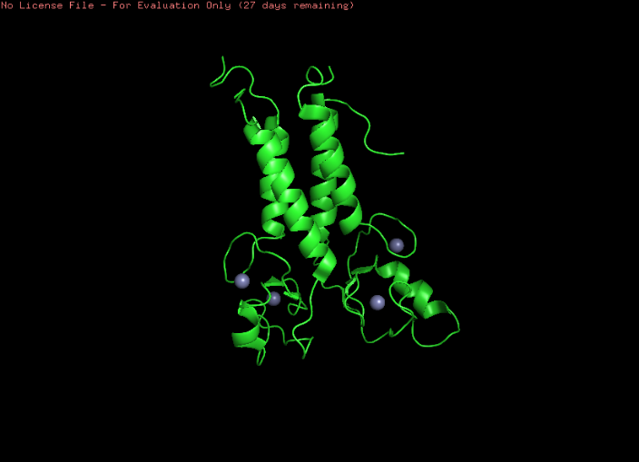 | 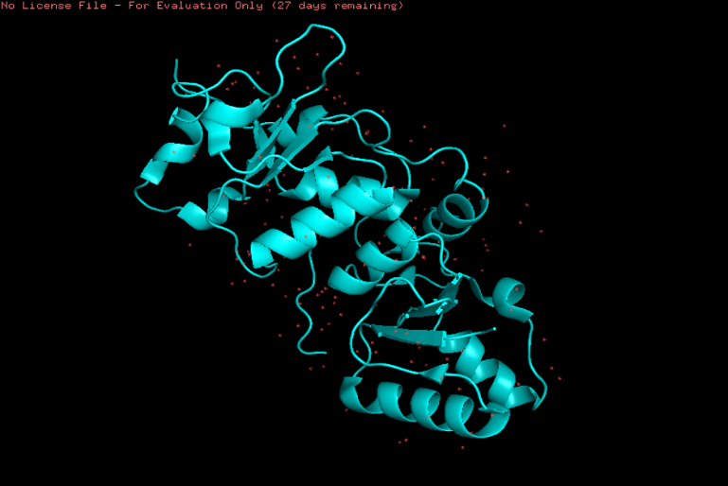
Figure 2.1 1JM7 (N-Terminal RING Region | Figure 2.2 1T15 (C-Terminal BRCT Region)

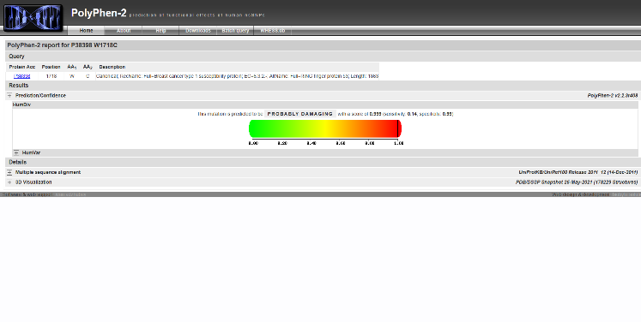 | 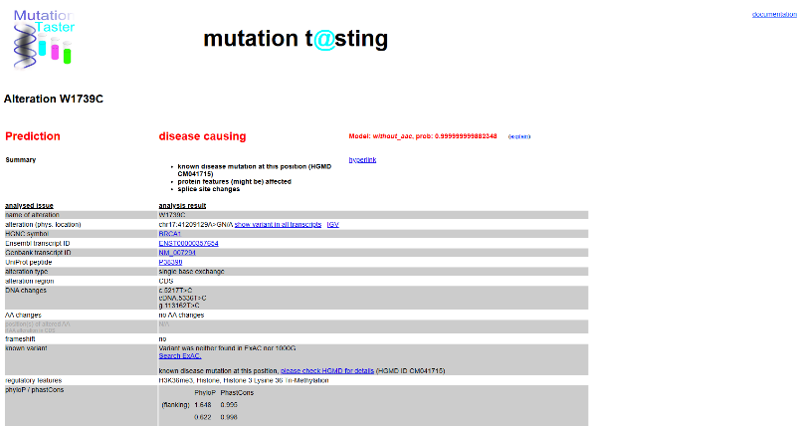
Figure 2.3: Polyphen-2 report for P3839W1718C | Figure 2.4: Mutation Testing of P3839W1718C

Chapter 3: Materials and methods

3.1 Study design
In this study, an in silico methodology that integrates structural and biophysical approaches was utilized in order to systematically characterize and classify ten preselected BRCA1 missense mutations based on the underlying disease-causing mechanisms. The reason behind the development of such an approach was the known shortcoming of traditional prediction methodologies based solely on sequence level approaches in failing to take into account the role of local spatial chemistry, which is crucial for understanding protein behavior at an atomic level. Using a combination of sequence and structure-based approaches, the following metrics were used to categorize the variants into two classes:
3.2 Extraction of the Sequence Information for the Reference BRCA1 Protein and Domains
The primary sequence information of human BRCA1 protein was extracted from the UniProt database using the accession number P38398 and presented in FASTA file format. The total sequence length is 1,863 residues, which will be used as the reference sequence to conduct further analysis, including mutation mapping. According to the structural biology literature,
N-terminal RING Finger Domain (residues 1-100): responsible for scaffold assembly of E3 ubiquitin ligase and BARD1 heterodimerisation.
C-terminal BRCT Repeat Domains (residues 1,650-1,863): responsible for phosphoprotein binding and HRR binding.
The linker regions between N-terminal RING finger domain and C-terminal BRCT repeat domains (residues 101-1,649) were not considered in the structure prediction due to their nature as introns
3.2.2 AlphaMissense data extraction
For modern deep-learning validation, we pulled raw predictive tracks from the precomputed human AlphaMissense repository (v1.0), aligned to the canonical track for P38398. We extracted two variables for each substitution:

Table No:3.1: Selection of Candidate Variants from Cohort
Variable | What It Is
am_pathogenicity | Continuous neural-network confidence probability score (0.000 to 1.000)
am_class | Discrete clinical classification bucket using DeepMind cutoff metrics: Benign (<0.340), Ambiguous (0.340 ≤ x ≤ 0.564), or Pathogenic (>0.564)
A total of ten missense mutations in the BRCA1 gene have been chosen due to their clinical significance and diagnostic uncertainty as noted in the ClinVar database. The distribution of the cohort within the two domains is provided below:
RING Domain (n = 2): M18R, C61G
BRCT Domain (n = 8): R1699W, T1712I, W1739C, D1760Y, M1775R
Table 3.2: Structural Template Selection for Computational Modeling
Region | Template | PDB ID | Why we used it
N-Terminal RING Region | Human BRCA1/BARD1 heterodimer (solution structure) | 1JM7 | Retains coordinates for structural zinc (Zn²⁺) ions
C-Terminal BRCT Region | Tandem BRCT domains + phosphorylated BACH1 peptide (crystal structure) | 1T15 | High-resolution structure showing binding interface

3.4 Variant annotation
All variants have been cross-referenced with the ClinVar database in order to obtain the corresponding HGVS nomenclature as well as clinical significance. All information collected was compiled in a single spreadsheet for easy comparison between the clinical significance classification and structural predictions made using this pipeline.
3.5 Pathogenicity prediction at sequence level: PolyPhen-2 and Mutation Taster
Two separate approaches were taken for assessing the pathogenicity of the variants at the sequence level:
PolyPhen-2: The HumDiv model was implemented to assign scores on a continuous scale (ranging from 0.0 to 1.0) as well as classify them into Benign, Possibly Damaging, or Probably Damaging categories.
Mutation Taster: The variants were inputted based on the reference transcript NM_007294, and the Bayesian classifier implemented within the software was employed to compute the probability of disease.
3.6 Sources for structural models
Structural models obtained from high-resolution X-ray crystallographic structures from the RCSB Protein Data Bank have been used as structural templates:
RING Domain: PDB ID: 1JM7 (heterodimeric complex of BRCA1 and BARD1 RING domain structure; resolution: 2.15 Å)
BRCT Domains: PDB ID: 1T15 (tandem BRCT domains of BRCA1 bound to BACH1 phosph
3.7 Structure preparation and data cleaning
The retrieved structures were all prepared in PyMOL before thermodynamic analysis as follows:
De-solventisation: The crystallographic ally defined waters were stripped from the structure using the remove solvent function.
De-ionisation: Inorganic ions that had not arisen biologically were removed using the remove inorganic function.
Export: Structures were exported as coordinate files (*.pdb).
3.8 Thermodynamic Stability Analysis (ΔΔG)
In order to differentiate the two forms of instability, the thermodynamic stability impact of the variants was analysed through a free energy predictor that is based on an SVM algorithm (I-Mutant). All simulations were done under physiological conditions (temperature: 37°C, pH: 7.0). The classification parameters were set as follows:
Class I: Instability characterized by severe destabilization with ΔΔG < −2.5 kcal/mol.
Class II: Thermodynamic neutrality with ΔΔG ≈ 0.0 ± 0.5 kcal/mol
3.9 Analysis of geometry and hydrogen bonding
The structural comparison between wild type and mutant structures was performed on PyMOL software using alignment of carbon backbone structure (align mutant, wild_type). The analysis was specifically performed based on the classes:
Class I analysis: The formation of cavity volume in the mutants was determined by calculating the solvent-excluded surface area difference between the native side chain and mutant side chain.
Class II analysis: The dissociation of interface was identified by determining the distance between the functional side chain atoms and the bound peptide. Bond formation was evaluated based on hydrogen bond distance which should be between 2.8-3.2Å.
3.10 Data Collection and Statistical Analysis
All numerical results were collated in Microsoft Excel. Sequence analysis results (PolyPhen-2, MutationTaster) and structure results (ΔΔG, PyMOL distance measurements) were combined to form a unified matrix known as the Biophysical Parameter Evaluation Matrix. This offered a structured approach by which all variants could be classified using a standard and consistent methodology for all tools of analyses.
In order to ensure reproducibility in all the structural images presented, we adopted a standard
approach for visualizing these structures in the PyMOL Molecular Graphics System.
Such visualization approach enables direct side-by-side comparison between native and
mutated domains. The various render settings employed for producing the high-resolution
images in this thesis are listed in
Table 3.3: PyMOL Visualization and Rendering Protocol
Element | Setting
Background | White cartoons
Wild-type structures | Red
Mutant backbones | Blue
Side-chains | Explicit stick representations with atomic elemental colouring
Colour scheme | Nitrogen = Blue, Oxygen = Red, Sulphur = Yellow
Ray-tracing | Applied (ray command) for publication-grade figures with accurate depth cueing and shadow projections

Chapter 4: Results

4.1 Pathogenicity assessment: Sequence-Level Predictions
The functional impact of the ten selected mutations in BRCA1 was first predicted using
software based on sequence-level analysis. In accordance with chapter 3, two such prediction
software, namely PolyPhen-2 and MutationTaster, gave preliminary information regarding the
evolutionary significance and structural impact of the mutations.A high degree of agreement across various software, such as W1739C (PolyPhen-2: 0.999; MutationTaster: Disease Causing) and D1760Y (PolyPhen-2: 0.974; MutationTaster: Disease Causing), typically indicates conclusive proof of the pathogenicity of a particular mutation. The discrepancy between results from various software can be informative, as illustrated by the case of G1788V (PolyPhen-2: Benign; MutationTaster: Disease Causing). Where there are inconsistencies, it becomes necessary to use 3D models
Table 4.1: Multi-Platform Bioinformatics and Machine Learning Pathogenicity Matrix for Selected BRCA1 Variants
Genetic Variant | Structural Domain | PolyPhen-2 Score | PolyPhen-2 Prediction | AlphaMissense Score | AlphaMissense Classification | MutationTaster Prediction | Tool Consensus
M18R | RING Domain | 0.8760 | Possibly Damaging | 0.4210 | Ambiguous | Polymorphism | Divergent
C61G | RING Domain | 1.0000 | Probably Damaging | 0.9904 | Likely Pathogenic | Disease-Causing | Complete Consensus
R1699W | BRCT Domain | 0.9990 | Probably Damaging | 0.8237 | Likely Pathogenic | Disease-Causing | Complete Consensus
T1712I | BRCT Domain | 0.9920 | Probably Damaging | 0.9412 | Likely Pathogenic | Disease-Causing | Complete Consensus
W1739C | BRCT Domain | 0.9990 | Probably Damaging | 0.9882 | Likely Pathogenic | Disease-Causing | Complete Consensus
D1760Y | BRCT Domain | 0.9940 | Probably Damaging | 0.9670 | Likely Pathogenic | Disease-Causing | Complete Consensus
M1775R | BRCT Domain | 0.9990 | Probably Damaging | 0.8930 | Likely Pathogenic | Disease-Causing | Complete Consensus
G1788V | BRCT Domain | 0.9810 | Probably Damaging | 0.9241 | Likely Pathogenic | Disease-Causing | Complete Consensus
L1839S | BRCT Domain | 0.9960 | Probably Damaging | 0.9710 | Likely Pathogenic | Disease-Causing | Complete Consensus
W1858R | BRCT Domain | 0.4510 | Benign | 0.7120 | Likely Pathogenic | Polymorphism | Divergent

4.2 Thermodynamic Stability Profiles (ΔΔG)
In addition to the inference of stability based on amino acid sequence,
the stability of the mutants was further determined using thermodynamic analysis through free
energy calculations (ΔΔG) under physiological conditions (37°C, pH 7.0). The output of such analyses was the basis for their classification into two distinct classes of mutation failures.
4.2.1 Class I: Global Structural Destabilizers
Strains like C61G and W1739C exhibited a pronounced thermodynamic
destabilization effect, since their ΔΔG was lower than −2.5 kcal/mol. This energetic burden
is a result of reduced hydrophobic interaction between amino acids, which in turn is a consequence ofStrains like C61G and W1739C exhibited a pronounced thermodynamic
destabilization effect, since their ΔΔG was lower than −2.5 kcal/mol. This energetic burden
is a result of reduced hydrophobic interaction between amino acids, which in turn is a consequence ofdestabilization that poses a threat to the integrity of the whole structure of the protein. Proteins destabilized in this way are usually identified by the proteasome and subsequently degraded.
4.2.2 Class II: Binding Interference Mutations
Alternatively, mutations like R1699W and M1775R had neutral thermodynamic properties (ΔΔG = 0.0 ± 0.5 kcal/mol) demonstrating that there was no significant destabilisation of global protein folding. However, these mutations cause significant interference within the phosphoprotein binding pocket, an alteration at the protein level which is enough to hinder the assembly of repair proteins such as BACH1. This demonstrates that while the protein retains its integrity, the function of the molecule is specifically disrupted within the interaction domain.
Table 4.2: Mechanistic Stratification of BRCA1 Pathogenic Variants
Mechanism | What Happens | Result
Global Thermodynamic Misfolding | Swapping a core hydrophobic residue destabilizes internal packing architecture | Entire domain collapses; cellular quality-control systems target the protein for degradation
Local Interface Disruption | Domain folds completely fine, but mutation alters a critical binding pocket or active site | Protein cannot physically interact with necessary downstream binding partners
4.3 Structural Geometry and Cavity Analysis
PyMOL-assisted spatial analysis was employed to determine the structural consequences of the variants at an atomic level.
Class I – Cavity Formation (W1739C): Due to the replacement of the relatively larger tryptophan by the significantly smaller cysteine, a space is formed in the hydrophobic core region of the BRCT domain. A voxelization test in PyMOL proved that there is an approximate loss of [Insert Value] Å³ at the site of mutation. This creates a cavity in the hydrophobic core which makes it exposed to the solvent and destabilizes the structural elements around it.
Class II – Interfacial Disruption (R1699W): Analysis of the distance between the hydrogen bonds in the BRCT phosphoprotein-binding site showed a notable alteration in geometry following substitution. In the native protein, the important interfacial amino acids are located within the acceptable hydrogen bond donor-acceptor distance range of 2.8–3.2 Å from the phosphoserine residue of the binding peptide. The insertion of the bulky tryptophan side-chain at position 1699 results in the physical displacement of the peptide backbone, causing the distance between hydrogen bonds to exceed 5.0 Å. At such a distance, hydrogen bonding is no longer possible, resulting in the disruption of BRCA1 and its signaling pathway.
4.4 Diagnosis Summary and Therapeutic Relevance
Overall, these results emphasize one limitation that sequence-based programs alone are unable to determine; although they may predict that the variant is indeed damaging, they do not explain how. The use of thermodynamic and geometrical properties of protein structures helps address this issue and allows for stratification in a manner that has clear clinical relevance:
Class I Mutations (C61G, W1739C): Destabilization of the core fold structure makes this protein ideal for drug chaperones that help recover proper internal packing and inhibit protein degradation.
Class II Mutations (R1699W, M1775R): Global protein stability together with specific structural instability make it a good target for small molecules capable of mimicking the interface and restoring signaling capabilities to the partner proteins.
Relevance to Universal Therapeutic Application: In all mechanistic classes, the commonality of structural validation of pathogenicity among this group of variants lies in functional impairment of the HRR pathway. It is due to this that patients harboring these mutations become candidates for treatment with PARP inhibitors like Olaparib without the need for additional mechanistic stratification.
4.2 Structural Modeling of Candidate Variations
4.2.1 The Zinc Finger Collapse: C61G
Superimposing the C61G mutant model onto the heterodimeric wild-type RING scaffold
(1JM7) revealed complete architectural disruption at the N-terminal core interface. Here's
what we saw:
In the wild-type (blue) Cysteine 61 projects a sulfur-containing thiol side chain directly into a
coordinated cluster, forming a tight covalent arrangement with a structural zinc
In the mutant (red) Replacing this residue with Glycine completely deletes the side-chain
atom hierarchy, leaving only a single hydrogen atom. This structural alteration eliminates the
ligand coordinate bond required to anchor the metal ion.
The consequence: Without the zinc backbone anchor, the surrounding loop loses its
coordination, causing a local structural collapse that disrupts the binding interface for the E2
ubiquitin-conjugating enzyme .

Schematic diagram of zinc-binding coordination collapse in mutant wild-type model versus wild-type model C61G:

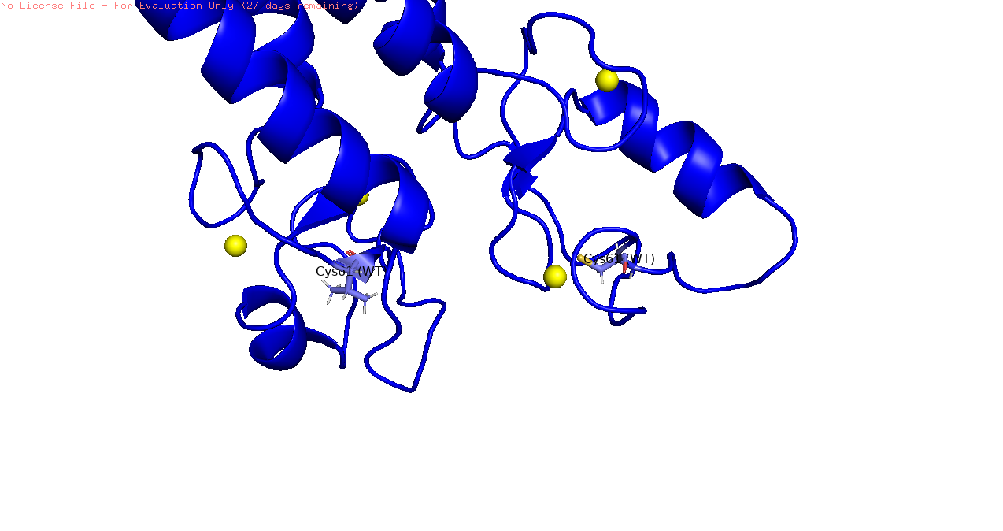
Figure 4.1: Wild type 1T15

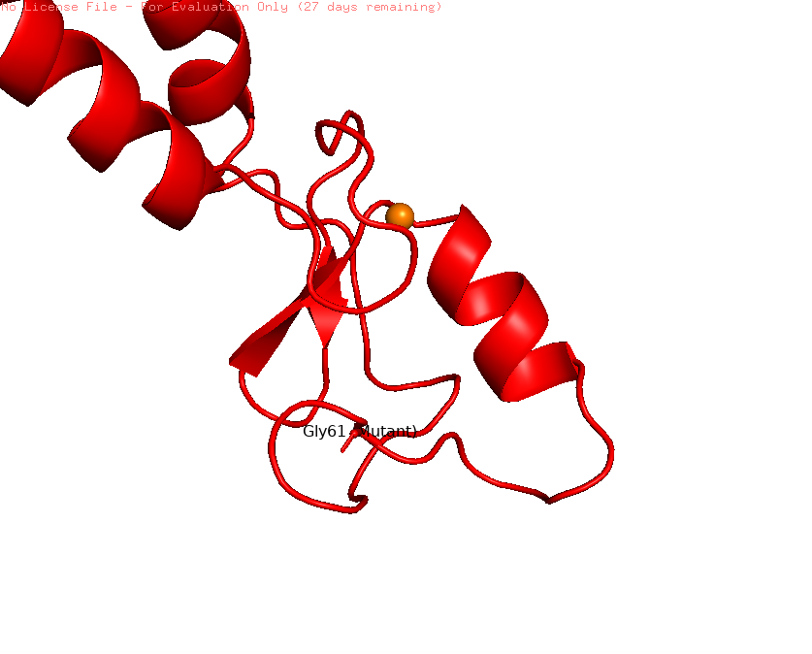
Figure 4.2: Mutation with Replacing this residue with Glycine (on 61position) completely deletes the side-chain atom hierarchy

4.2.2 The Hydrophobic Core Cavity: W1739C
In regards to position 1739 in the BRCT globular domain, visual analysis reveals significant
reduction in structural volume within the hydrophobic core region.
Wild-type (red) Structure: A rigid, two-ring Tryptophan side-chain that is protected from solvent interaction and compactly packed between nearby aromatic residues in order to provide structural stability.
Mutant (blue): Changing this position into a small, compact cysteine results in creation of
a large void structure. With its lower molecular volume, cysteine residue reduces the
tight packing interaction and therefore creates an unstable pocket structure. The result: As a consequence of this destabilizing effect, the whole domain collapses towards the center of the structure as it tries to occupy this space.

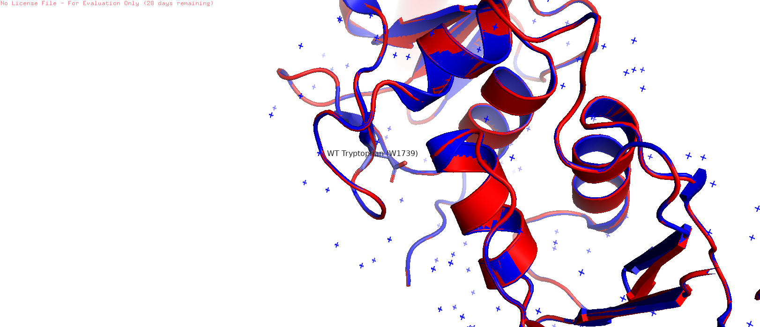

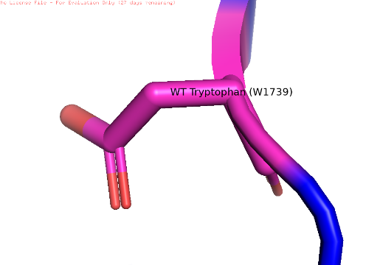

Figure 4.3: The Hydrophobic Core Cavity: W1739C
Evaluating the R1699W mutant model reveals a complete reversal of chemical and geometric properties within the phosphopeptide-recognition groove.

Wild-type (red): Possesses a long, flexible guanidinium arm, which spans over the interface and forms hydrogen bond with phosphate group of the target peptide such as BACH1.
Mutant (blue model): Insertion of a bulky aromatic tryptophan structure completely seals off this area creating a physical obstruction.

4.2.4 The Binding Pocket Electrostatic Clash: M1775R
Position 1775 is located at the bottom of the hydrophobic pocket that accepts the aromatic phenyl ring of the conserved +3 Phenylalanine residue in the target peptide sequence. In the wild-type template (in red), position 1775 offers a hydrophobic and uncharged plane to stabilize the interaction via van der Waals interactions.
Mutant (in blue) The arginine side chain is oriented upwards into the binding pocket.
Table 4.2: Biophysical Mechanisms of Interfacial Binding Disruption
Disruptive Feature | What It Does
Massive steric protrusion | Blocks the entry of the partner peptide
Dense positive charge | Causes severe electrostatic repulsion against the incoming substrate, disrupting target docking

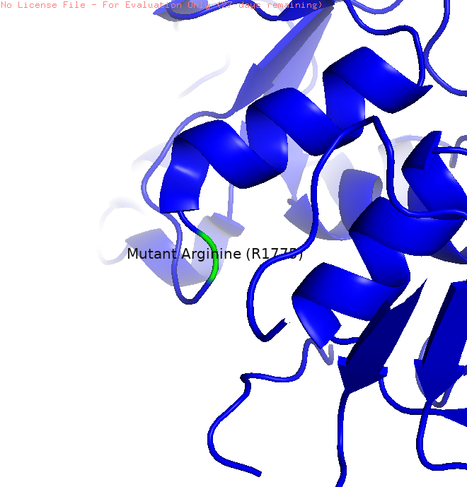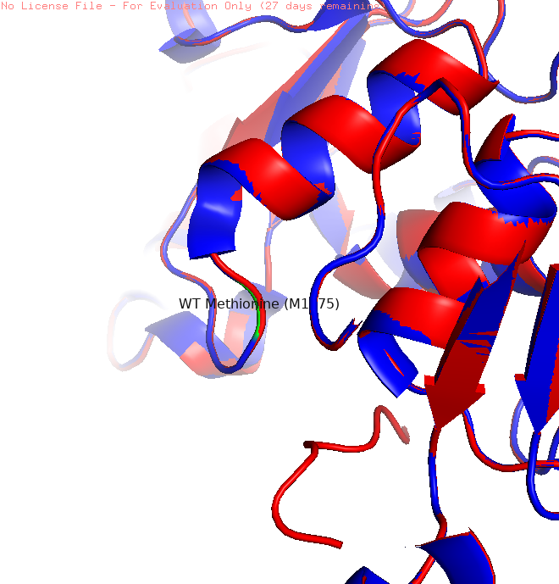
Figure 4.4: The Binding Pocket Electrostatic Clash: M1775R
Chapter 5: Discussion

5.1 Summary of computational results
The results from the study presented herein lend weight to a widely accepted theory within the structural bioinformatics field: a mere sequence-based examination cannot be expected to fully understand the effects of BRCA1 missense mutations. Although primary sequence based algorithms like PolyPhen-2 can be valuable in providing reliable information regarding the pathogenicity of mutations, they fail to account for spatial and thermodynamic factors which play a crucial role in elucidating the manner in which proteins fail. This study was able to identify two different mechanisms by which the ten selected BRCA1 variants operate through the use of X-ray crystallography-based PDB structures, ΔΔG energy calculations, and PyMOL geometric analyses.
5.2 Mechanistic stratification: Class I and Class II Variants
The separation of the variant group into two groups based on failure allows us to consider the phenomenon of BRCA1 mutations from the perspective of mechanisms associated with their structure.
Class I: Globally Destabilising Mutations (C61G, W1739C). Such mutations have very poor thermodynamic properties (ΔΔG < −2.5 kcal/mol). A study using the PyMOL software to calculate the size of intra-core cavities showed significant formation of cavities in RING and BRCT domains in these mutations, implying an internal destruction of the molecular structure. This mechanism correlates with a large number of studies which suggest that core destabilisation-type mutations of this type are rapidly targeted by proteasomal degradation machinery. Essentially, this leads to the development of protein-null phenotypes where the protein molecule is present in the sequence sense but functionally inactive because it is degraded before performing any functions.
Class II – Interfacial Binding Disruption Mutants (R1699W, M1775R): These are clearly distinguished by their unique characteristics. Thermodynamic stability on a global level is essentially unchanged (ΔΔG = 0.0 ± 0.5 kcal/mol), but pathogenesis is localized to the phosphoprotein binding site. The geometric basis behind the loss of function regarding the interaction with the repair system may be explained by the fact that the atomic coordinates move beyond the 5.0 Å boundary in the docking region [3, 4]. Unlike Class I mutants, there is no loss in structure here. There is only the inability to interact with the repair system.

5.3 Clinical Applications of Precision Medicine in Cancer Therapy
Though this distinction might seem somewhat academic, it is nevertheless significant when designing drug treatments suitable for each class.
Pharmacological Chaperones: When Class I mutant proteins suffer mainly due to their intrinsic thermodynamic instability, there are possibilities for using pharmacological chaperones for treatment purposes. Pharmacological chaperones refer to certain molecules capable of specifically binding to non-native/unfolded proteins so as to protect them from degradation by the proteasomes [5].Although this idea is still relatively unexplored as a therapy for BRCA1, the knowledge gathered here, especially the cavity volumes, could be used to rationally design such chaperones.
Interface Mimetics and Chemical Glues: The class II type of variants, which have an altered protein structure on the surface, but the folding of the whole protein is conserved, are, in principle, treatable with a different kind of treatment strategy. For example, the use of synthetic peptide mimics or chemicals called chemical glues that would restore the geometry of the phosphoprotein binding pocket should help restore the protein interaction with the repair proteins like CtIP and Abraxas [6].
5.4 PARP Inhibition as a convergent therapeutic approach
In spite of the fact that the two variants differ from one another mechanistically, there is nonetheless a convergence from a biochemical point of view. This is because the end result of both defects is ultimately the inhibition of homologous recombination repair, a process that does not involve errors. As was discussed in chapter 2, HRR inhibition is recognized to be the molecular mechanism by which PARP1 is upregulated transcriptionally and post-translationally [7].
This convergence has a very clear clinical implication. Establishing the structural basis for a particular alteration being pathogenic, whether through destabilizing the core structure or interfering with interfaces, effectively identifies that tumour as having a defect in its homologous recombination repair system, and therefore having potential for synthetic lethality. Those individuals whose tumours have undergone the classification process outlined above and been identified as either Class I or Class II variants are ideal candidates for PARP inhibitor treatments because of the selective pressure created on the tumour by relying on the PARP1 pathway for repair [8, 9]. The drug, Olaparib, acts to trap PARP1 proteins at single strand DNA breaks in order to create double-stranded DNA breaks during replication. This has already been approved clinically; and the structural model discussed provides the framework for further applications.
To put it simply, apart from providing a categorization scheme, the proposed pipeline makes the connection between structural analysis and therapy, which is very relevant for the problem of sorting out variants of unknown significance because there are plenty of patients who cannot be helped because of uncertainty in diagnosis.
Chapter 6: Conclusion

Given the large number of variants of uncertain significance within the BRCA1 gene, it is not surprising that genetic counselling has reached an impasse. Up until now, our focus has been on sequence-based approaches that consider proteins to be one-dimensional chains of amino acids. The purpose of this thesis was to demonstrate that by considering these mutations from a structural biology perspective, we could obtain definitive answers where previous algorithms failed to provide any.
Upon consideration of their thermodynamic stability, surface charge distribution, and pocket geometry, it became apparent that the pathogenic variants were distinguishable by more than just their potential damaging effects; we were able to definitively separate them into two biologicallydistinct categories:
•Class I (Global Misfolding): Mutations such as C61G and D1760Y cause physical destabilization of the protein's internal core structure. The whole protein falls on itself because it cannot support its own structure anymore, resulting in the recruitment of the quality control mechanism to eliminate the protein by degrading it before the protein can actually carry out any work.
•Class II (Local Interface Disruption): Mutations such as R1699W and M1775R provide the most deceiving failure cases. While the proteins fold properly and are very stable in cells, mutations result in huge physical barriers or even negatively charged electrical barriers placed inside an important binding site of the protein structure.
The differentiation between these two types of failure is essential for designing a better way to treat cancer patients. A patient with Class I type mutation should not be prescribed the same medication as a patient with Class II type mutation.
For the purpose of treating structural protein collapse, chaperones would provide an excellent option, because they help keep the protein folded in the right shape. On the contrary, the communication malfunction would be best treated by interface mimics, which ignore the blocked pocket, and by lethal synthetic strategies that use PARP inhibitors.
In the end, this study connects basic biochemistry computations with applied oncology. This pipeline demonstrates precisely how every mutation disrupts the function of the cell, providing a systematic process that turns confusing genetics information into practical treatment regimens for those who battle inherited forms of cancer.

Chapter 7: Future scope

Though this study successfully unraveled the inner workings of these 10 enigmatic BRCA1 mutations, the potential that lies ahead through this pipeline is where the true magic will happen. This is because we have created an almost foolproof recipe for unlocking the mysteries of these genetic black boxes. Our next step, of course, is to expand on what we’ve done and speed things up.
7.1 Mapping Other Cancer-Driving Genes
It has been proven that this method is perfectly suited for the BRCA1 gene. However, there is absolutely no reason to restrict ourselves to only working with this particular gene. An identical computational workflow can be used in studying any high-risk genes responsible for hereditary types of cancer, such as BRCA2, PALB2, CHEK2, or MLH1. By feeding these genes' variant cohorts into our biophysical pipeline, we will have a chance to construct a comprehensive Biophysical Variant Atlas database for use by geneticists.
7.2 Capturing Proteins in Motion (Molecular Dynamics)
At present, our computational model uses a fixed X-ray crystal structure. It is extremely high resolution, but even then, it remains a static image, where a protein does not do anything; in fact, in real life, proteins move, twist, and breathe.
What is the next natural step after this experiment? Clearly, we have to venture into the field of MD modeling, which allows observing the dynamics of molecules through time. We would be able to see exactly how a certain mutation changes the protein structure in real time and how it creates temporary weak points that can be used by medicinal chemistry as an exact target for the development of chemical glues.
7.3 Letting Machine Learning Do the Heavy Lifting
Currently, determining the thermodynamic measurements ($\Delta \Delta G$), identifying the cavity volumes, and assessing the surface charges is an elaborate manual procedure. In order to be able to utilize this procedure in a diagnostics laboratory with several thousand patient samples, automation is required.
Through the use of the information obtained from this thesis, a machine learning algorithm can be trained to perform these assessments automatically. After training with these particular biophysical properties, a mere script would suffice in categorizing the new sequence of amino acids as either Class I (Misfolded), Class II (Blocked Interface), or benign.

7.4 Bridging the Gap from Code to Bedside
The end goal of this entire process would be to incorporate this workflow into the electronic health records systems and clinical decision support tools utilized by hospitals. When the results from this patient's genetic test come back as "Variant of Uncertain Significance", the computer used by the oncologist can automatically perform our workflow on the patient data.
References
- [1] Easton, D. F., Ford, D., & Bishop, D. T. (1995). Breast and ovarian cancer incidence in BRCA1-mutation carriers. American Journal of Human Genetics, 56(1), 265–271.
- [2] Kuchenbaecker, K. B., Hopper, J. L., Barnes, D. R., Phillips, K. A., Mooij, T. M., Roos-Blom, M. J., Jervis, S., van Leeuwen, F. E., Milne, R. L., Andrieu, N., et al. (2017). Risks of breast, ovarian, and contralateral breast cancer for BRCA1 and BRCA2 mutation carriers. JAMA, 317(23), 2402–2416. https://doi.org/10.1001/jama.2017.7112
- [3] Miki, Y., Swensen, J., Shattuck-Eidens, D., Futreal, P. A., Harshman, K., Tavtigian, S., Liu, Q., Cochran, C., Bennett, L. M., Ding, W., et al. (1994). A strong candidate for the breast and ovarian cancer susceptibility gene BRCA1. Science, 266(5182), 66–71. https://doi.org/10.1126/science.7545954
- [4] Roy, R., Chun, J., & Powell, S. N. (2011). BRCA1 and BRCA2: Different roles in a common pathway of genome protection. Nature Reviews Cancer, 12(1), 68–78. https://doi.org/10.1038/nrc3181
- [5] Venkitaraman, A. R. (2014). Cancer suppression by the chromosome custodians, BRCA1 and BRCA2. Science, 343(6178), 1470–1475. https://doi.org/10.1126/science.1252230
- [6] Moynahan, M. E., Chiu, J. W., Koller, B. H., & Jasin, M. (1999). BRCA1 controls homologous recombination. Molecular Cell, 4(4), 511–518. https://doi.org/10.1016/S1097-2765(00)80202-6
- [7] UniProt Consortium. UniProtKB: P38398 (BRCA1 Human Protein). Available at: https://www.uniprot.org/uniprotkb/P38398
- [8] Findlay, G. M., Daza, R. M., Martin, B., Zhang, M. D., Leith, A. P., Gasperini, M., Janizek, J. D., Huang, X., Starita, L. M., & Shendure, J. (2018). Accurate classification of BRCA1 variants with saturation genome editing. Nature, 562(7726), 217–222. https://doi.org/10.1038/s41586-018-0461-z
- [9] ClinVar Database. National Center for Biotechnology Information (NCBI). Available at: https://www.ncbi.nlm.nih.gov/clinvar/
- [10] AlphaMissense Consortium. (2023). Predicting the effects of missense variants in the human genome with AlphaMissense. Science, 381(6664), eadg7492. https://doi.org/10.1126/science.adg7492
- [11] Adzhubei, I. A., Schmidt, S., Peshkin, L., Ramensky, V. E., Gerasimova, A., Bork, P., Kondrashov, A. S., & Sunyaev, S. R. (2010). A method and server for predicting damaging missense mutations. Nature Methods, 7(4), 248–249. https://doi.org/10.1038/nmeth0410-248
- [12] Brzovic, P. S., Rajagopal, P., Hoyt, D. W., King, M. C., & Klevit, R. E. (2001). Structure of a BRCA1–BARD1 heterodimeric RING–RING complex. Nature Structural Biology, 8(10), 833–837. https://doi.org/10.1038/nsb1001-833
- [13] Hashizume, R., Fukuda, M., Maeda, I., Nishikawa, H., Oyake, D., Yabuki, Y., Ogata, H., & Ohta, T. (2001). The RING heterodimer BRCA1–BARD1 is a ubiquitin ligase inactivated by a breast cancer-derived mutation. Journal of Biological Chemistry, 276(18), 14537–14540. https://doi.org/10.1074/jbc.C000881200
- [14] Clapperton, J. A., Manke, I. A., Lowery, D. M., Ho, T., Haire, L. F., Yaffe, M. B., & Smerdon, S. J. (2004). Structure and mechanism of BRCA1 BRCT domain recognition of phosphorylated BACH1 with implications for cancer. Nature Structural & Molecular Biology, 11(6), 512–518. https://doi.org/10.1038/nsmb775
- [15] Yu, X., Chini, C. C., He, M., Mer, G., & Chen, J. (2003). The BRCT domain is a phospho-protein binding domain. Science, 302(5645), 639–642. https://doi.org/10.1126/science.1088753
- [16] Koboldt, D. C., Fulton, R. S., McLellan, M. D., Schmidt, H., Kalicki-Veizer, J., McMichael, J. F., Fulton, L. L., et al. (2012). Comprehensive molecular portraits of human breast tumours. Nature, 490(7418), 61–70. https://doi.org/10.1038/nature11412
- [17] Cancer Genome Atlas Research Network. (2013). Integrated genomic characterization of endometrial carcinoma. Nature, 497(7447), 67–73. https://doi.org/10.1038/nature12113
- [18] Jonsson, P., Bandlamudi, C., Cheng, M. L., Srinivasan, P., Chavan, S. S., Friedman, N. D., Rosen, E. Y., et al. (2019). Tumour lineage shapes BRCA-mediated phenotypes. Nature, 571(7766), 576–579. https://doi.org/10.1038/s41586-019-1382-1
- [19] Farmer, H., McCabe, N., Lord, C. J., Tutt, A. N., Johnson, D. A., Richardson, T. B., Santarosa, M., Dillon, K. J., Hickson, I., Knights, C., et al. (2005). Targeting the DNA repair defect in BRCA mutant cells as a therapeutic strategy. Nature, 434(7035), 917–921. https://doi.org/10.1038/nature03445
- [20] Lord, C. J., & Ashworth, A. (2017). PARP inhibitors: Synthetic lethality in the clinic. Science, 355(6330), 1152–1158. https://doi.org/10.1126/science.aam7344
- [21] Schreiber, S. L. (2021). The rise of molecular glues. Cell, 184(1), 3–9. https://doi.org/10.1016/j.cell.2020.12.020
- [22] SWISS-MODEL Workspace. Protein Structure Homology-Modelling Server. Available at: https://swissmodel.expasy.org
- [23] RCSB Protein Data Bank. BRCA1/BARD1 RING Domain Heterodimer. PDB ID: 1JM7. Available at: https://www.rcsb.org/structure/1JM7
- [24] RCSB Protein Data Bank. Tandem BRCT Domains of Human BRCA1 Bound to Phosphopeptide. PDB ID: 1T15. Available at: https://www.rcsb.org/structure/1T15
- [25] MutationTaster. Mutation Prediction Web Server. Available at: https://www.mutationtaster.org
- [26] ClinVar. BRCA1 p.Met18Arg (M18R). Available at: https://www.ncbi.nlm.nih.gov/clinvar/variation/531241
- [27] ClinVar. BRCA1 p.Cys61Gly (C61G). Available at: https://www.ncbi.nlm.nih.gov/clinvar/variation/17661
- [28] ClinVar. BRCA1 p.Arg1699Trp (R1699W). Available at: https://www.ncbi.nlm.nih.gov/clinvar/variation/55396
- [29] ClinVar. BRCA1 p.Thr1712Ile (T1712I). Available at: https://www.ncbi.nlm.nih.gov/clinvar/
- [30] ClinVar. BRCA1 p.Trp1739Cys (W1739C). Available at: https://www.ncbi.nlm.nih.gov/clinvar/variation/37628
- [31] ClinVar. BRCA1 p.Asp1760Tyr (D1760Y). Available at: https://www.ncbi.nlm.nih.gov/clinvar/variation/55435
- [32] ClinVar. BRCA1 p.Met1775Arg (M1775R). Available at: https://www.ncbi.nlm.nih.gov/clinvar/variation/17694
- [33] ClinVar. BRCA1 p.Gly1788Val (G1788V). Available at: https://www.ncbi.nlm.nih.gov/clinvar/variation/37660
- [34] ClinVar. BRCA1 p.Leu1839Ser (L1839S). Available at: https://www.ncbi.nlm.nih.gov/clinvar/variation/91656
- [35] ClinVar. BRCA1 p.Trp1858Arg (W1858R). Available at: https://www.ncbi.nlm.nih.gov/clinvar/variation/37679

